Please Please if Change something, WRITE YOUR NAME ON IT.

This high current board shall distribute the current between all outputs, which will include all 4 Drivetrain motors + Excavation Motor + Deposition motor + Two Linear actuators.

Note: The jetson nano will be powered through external power supply, which will have separate Dc-Dc converter.

This board shall:

* Withstand up to 40 A peak current during transient and startup conditions.
* Provide a minimum of seven high-current outputs, in addition to one dedicated output for a DC-DC converter.
* Include a power indication LED to provide visual confirmation of board power status.
* Include fuses for each bus.
* Include reverse-polarity protection on the main input.
* Include decoupling capacitors.
* Include defined mounting holes.
* Include LED indication for each bus to easily identify a blown or faulted fuse.
* Support current-sensing capability for each output, with the understanding that this feature is intended for future implementation. For the initial revision, a single main bus current sensor (or a limited number of sensors) may be implemented to monitor overall system current consumption while preserving expandability for future upgrades.
* May include a built-in DC-DC step-down converter buck converter.
* May include Linear converter to 3.3v. However, we will probably not need that.

Some useful resources:

* [PCB Design Review: Power Meter Layout Deep Dive](https://www.youtube.com/watch?v=QA4w8Yg55Ek)

Here is my final design considerations:

I have been working on this project for a week, and your advice will be highly appreciated. This project aims to design a full power distribution board with fuses, current sensors, and DC-DC 5V converters.

Here are the details of this design:

* Used the KiCad trace width calculator to determine the trace width. I believe this calculator is based on the IPC-2221 standard.
* The copper thickness is 2 oz from the OSH manufacturer.
* Copper pour and ground plane.
  + Used the bottom layer as ground and the rest of the routing on the top layer.
* Stitching vias:
  + I know they are important for thermal relief, but I am not sure how many I should use in my design. Added them between the upper and lower ground planes.
* Copper pour for the power plane.
* Double layer for BLDC:
  + I used double-layer traces for the BLDC connectors because I found that a trace width of 5 mm would not be enough. I am not sure if this design will disturb the ground plane.
* Fuses:
  + I used standard blade fuses that can support up to 30 A.
* Current sensing
  + For my design, I need to power 5 BLDC motors, all of which have built-in current sensors, so I only needed four external sensors: one for the main line and three for the other two systems. I used the ACS758 and followed the recommended layout in the documentation in terms of the decoupling capacitor and RC filter on the output.
* Capacitors:
  + Used 1000 µF as the main capacitor. Used 100 µF for the motors. Used 10 µF for the other small systems.
* DC-DC buck converter:
  + Used the LM2596T-5 and followed the recommended layout from TI.
  + In the layout, they stated that I need to use 670 µF as the input capacitor and 330 µF as the output capacitor. However, the 670 µF was recommended based on the assumption that the 12 V input is not regulated. In my case, the input voltage should be regulated because it is coming from a battery.
  + I tried to place the DC-DC converter far away from the low-voltage analog signals to make sure there is no interference.
* Thermal relief:
  + I changed most of the high-current connectors to solid connections without thermal relief.

I would highly appreciate your feedback.

Thanks in advance.

Important: -

* 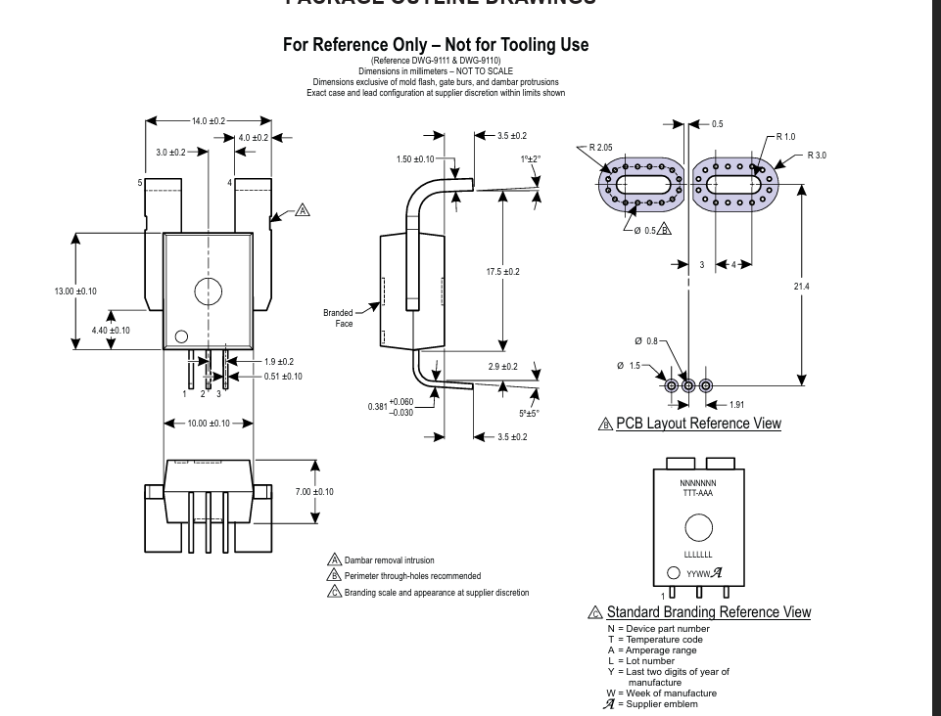
* Feedback:
* I don't like it.
* The switching regulator is a bad idea. It's an ancient chip which runs at low switching frequency (150kHz for the LM2596, 56-60 kHz for LM2576, and there's lots of fakes labeled 2596 but which actually run at the lower switching frequency) and this means you need to use big inductors and big input and output capacitors with it. Also, the efficiency is not great, you're looking at 75-85% efficiency at 2A+ of current - you won't be able to run the TO-220 version without a heatsink at 2A of current.
* I strongly suggest you use a synchronous rectifier regulator, something that runs in the 340kHz - 750kHz range - synchronous rectifier regulators use an internal mosfet instead of diodes so you won't need to add the equivalent of your 1n5822 diode, and the higher switching frequency will allow you to use smaller input and output capacitors.
* To give you some example of cheap synchronous rectifier regulators, have a look at
* AP64xxy / AP64xxyQ series from Diodes Inc: (xx = maximum current, y = variation, Q = version with extra validations for automotive use)
* AP64350 : <https://www.lcsc.com/product-detail/C2071691.html> / <https://www.digikey.com/en/products/detail/diodes-incorporated/AP64350SP-13/10420257>
* AP64350Q : <https://www.lcsc.com/product-detail/C5248545.html> / <https://www.digikey.com/en/products/detail/diodes-incorporated/AP64350QSP-13/12349218>
* AP64351 : <https://www.digikey.com/en/products/detail/diodes-incorporated/AP64351QSP-13/12349260>
* AP64351Q : <https://www.digikey.com/en/products/detail/diodes-incorporated/AP64351QSP-13/12349260>
* AP64352 : <https://www.lcsc.com/product-detail/C2071665.html?s_z=n_ap6435> / <https://www.digikey.com/en/products/detail/diodes-incorporated/AP64352SP-13/10420692>
* AP64352Q : <https://www.lcsc.com/product-detail/C5248547.html> / <https://www.digikey.com/en/products/detail/diodes-incorporated/AP64352QSP-13/12349255>
* Up to 40v input voltage, up to 3.5A output current, adjustable switching frequency or fixed 570kHz (for AP64352). AP64352 has compensation built in, so that version is attractive if you want least amount of components.
* For the adjustable switching frequency versions, you'd aim for the 500kHz switching frequency which is also used in the examples in the datasheet.
* For this regulator, they recommend a 5.5uH inductor for 5v output but inductors up to 10uH can be used - I would choose a 6.8uH inductor or even 8.2uH as they're much more common values / easier to get inductors. For this chip, you'd want an inductor with a current rating around 1.5x - 2x the maximum output current (or more), and a resistance as low as possible (less than 200mOhm should be fine).
* Example of such inductors with big pads, easy to solder by hand if needed : <https://www.lcsc.com/product-detail/C5189749.html> or <https://www.lcsc.com/product-detail/C207852.html>
* And for input and output capacitors, follow the datasheet... a couple 10uF ceramics rated for at least 35-50v on input (add a small 100-220uF 25v polymer capacitor if you want) , a couple 22uF ceramics on output rated for at least 16v (and add a small 270-470uF 10-16v polymer optionally)
* I have a feeling you aimed to make this board 100% through hole, and maybe you're reluctant to use this chip because of the footprint. But it's actually very easy to solder by hand. If you make the bottom pad a bit wider, you can apply a bit of solder on that pad, put a bit of flux over the bottom of the chip and over the solder, put the chip on top of the solder and then heat up the pad with the soldering iron - the solder will heat up and stick to the bottom of the chip. Then, you can easily go around and solder each leg of the chip to the pads, again it takes just a bit of flux and a solder iron with thinner tip.
* In the same note, through hole decoupling capacitors suck, and often those through hole are the cheaper X5R grade and they're becoming expensive, while 100nF X7R in 0805 / 0603 are quite cheap and very easy to solder even by hand. 0805 footprint is basically as easy to solder as a 0.1" spaced 2 pin component like a led or capacitor, you have 2mm - 2.5mm between pads.
* Examples : <https://www.lcsc.com/product-detail/C49678.html> or <https://www.lcsc.com/product-detail/C1711.html>
* I don't like how you bend those traces from the fuse to the output connectors. I would have a straight rectangle from the fuse to the output connector, making sure the output pin is surrounded with copper completely. I'd even widen this rectangle to the right by some amount. The output capacitor can be moved to the left a bit so that it's positive voltage pin is on that wide trace, and the negative pin can connect directly to a trace that comes up from the negative pin. If you use solid (polymer) capacitors, you should be able to easily fit there 100uF 25v in a small footprint, like 8mm diameter.
* The resistors for leds eating into the large voltage rectangle is a bit ugly. Again ... use surface mount resistors, 0805/1206 resistors are big and easy to solder.
* I don't like that your schematic is improperly labelled - many missing labels and reference designators. I don't like that your schematic and your PCB list your buck converter capacitors as different values. I don't like that you have doubled up the trace on the GND plane for your motors.
* Can you provide a proper schematic - with components all labelled - such as the diodes, and the resistor values?
* Can you make sure that it is readable? Even the text at the side - I will try double check your calculations and component selection if you can provide this information?

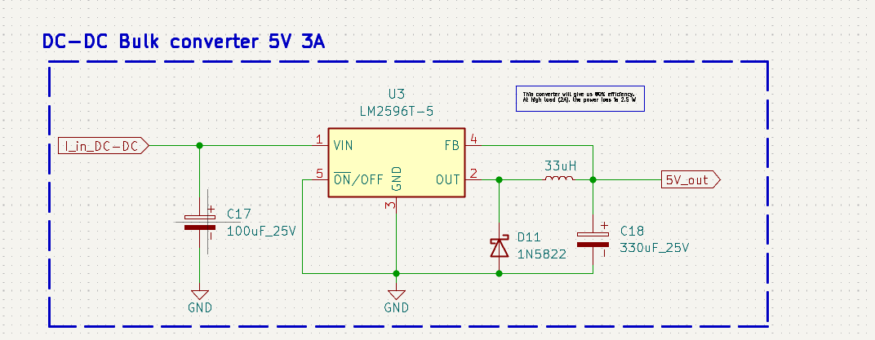

One layer

Increase via stitching 30A

NO VIA STITCHING

Adding the stitching vias at the current path 35A

Removed LED because they create areas of high current density. 35A

Remove the other layer and the via stitching: 35A

Add more Via stitching 35A

Organize vias 35A

